Survival Guide What Makes a Sentence?
- A sentence begins with a capital letter.
- A sentence ends with one of the following forms of punctuation:
  - A period.
  - An exclamation point!
  - A question mark?
- A sentence must have a subject and a predicate.
  - Subject- Identifies the person, place, thing or idea the sentence is about.
  - Predicate- Describes what the subject does or is.
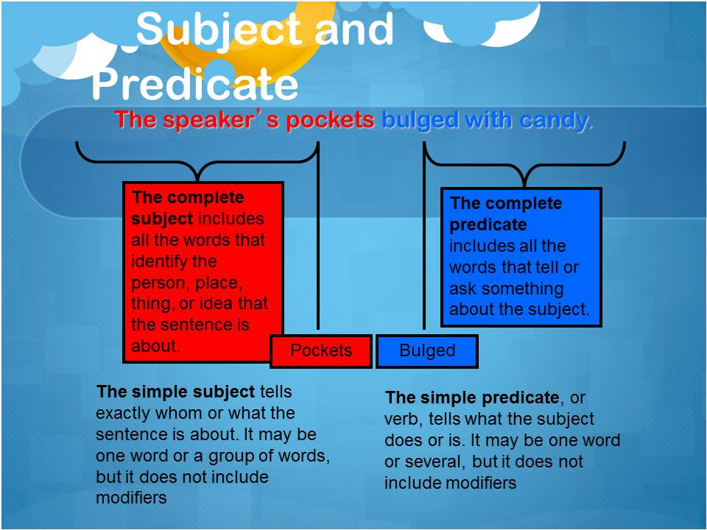
Possible methods of integrating sentence parts into your curriculum:
- Take sentences from your textbooks and/or articles related to your curriculum. Have students circle the subject and underline the predicate for a selected amount.
- Provide students with a subject related to your curriculum and have them create a variety of predicates that could accompany the subject.
  - Example: Subject- Abraham Lincoln
    - was the 16th president.
    - was a great public speaker.

