Ms. Lissette Alvarez
John A. Ferguson Senior High

- Go to the Ferguson website at http://ferguson.dadeschools.net/index.htm
- Select “Departments” from the “Faculty” section
- Select “Information Center”
- Select “Information Center Website”
- Select “Virtual Library” on the left
- Select “Secondary Resources”
- Select “Choices Explorer”, next to the Bidges icon.
- On the “Student Sign-In” page select “Create a new portfolio”
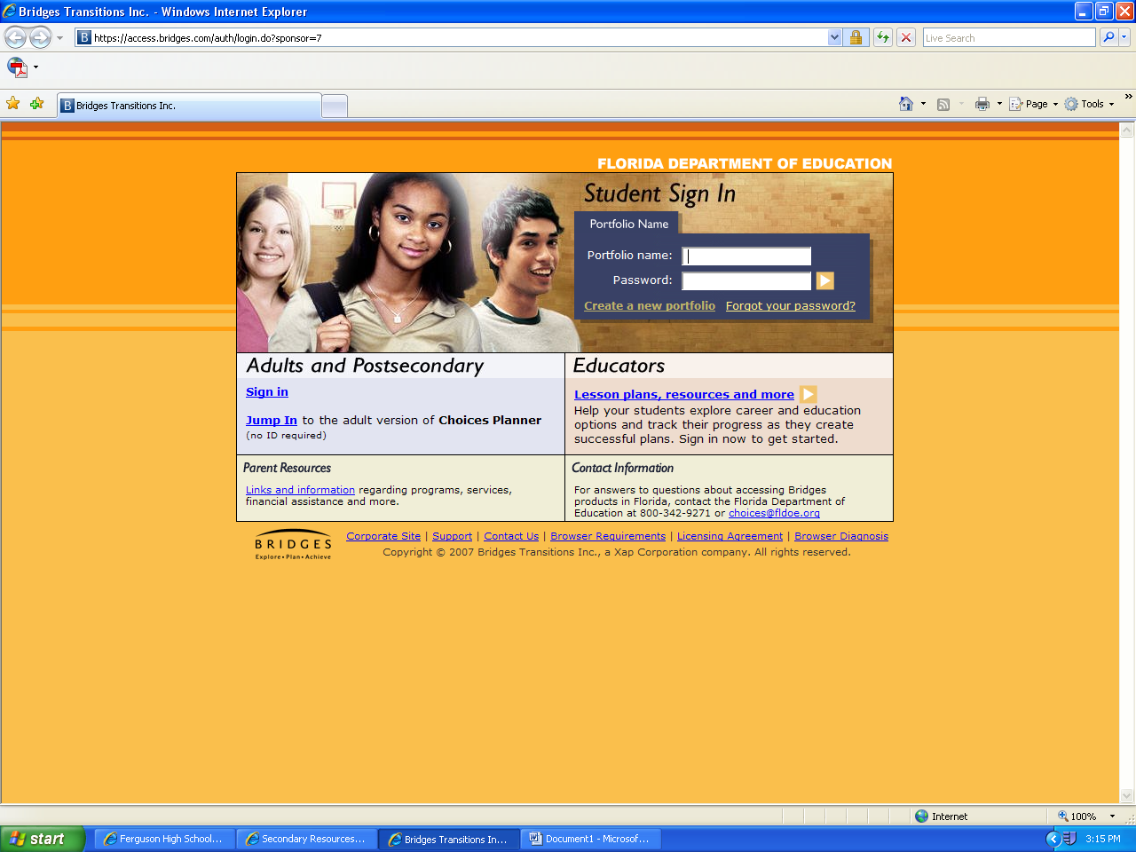

- Complete the form (the county is “Miami-Dade County” and for school select “John A. Ferguson”)
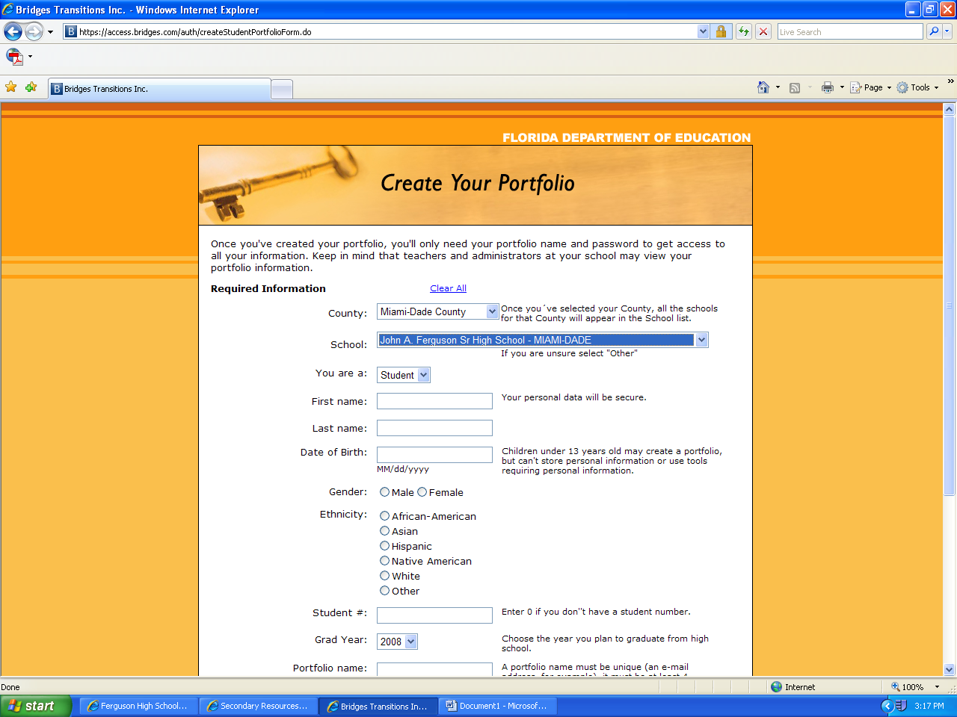
- Click on “Create your portfolio” at the bottom of the page

- Select “Choices Planner”
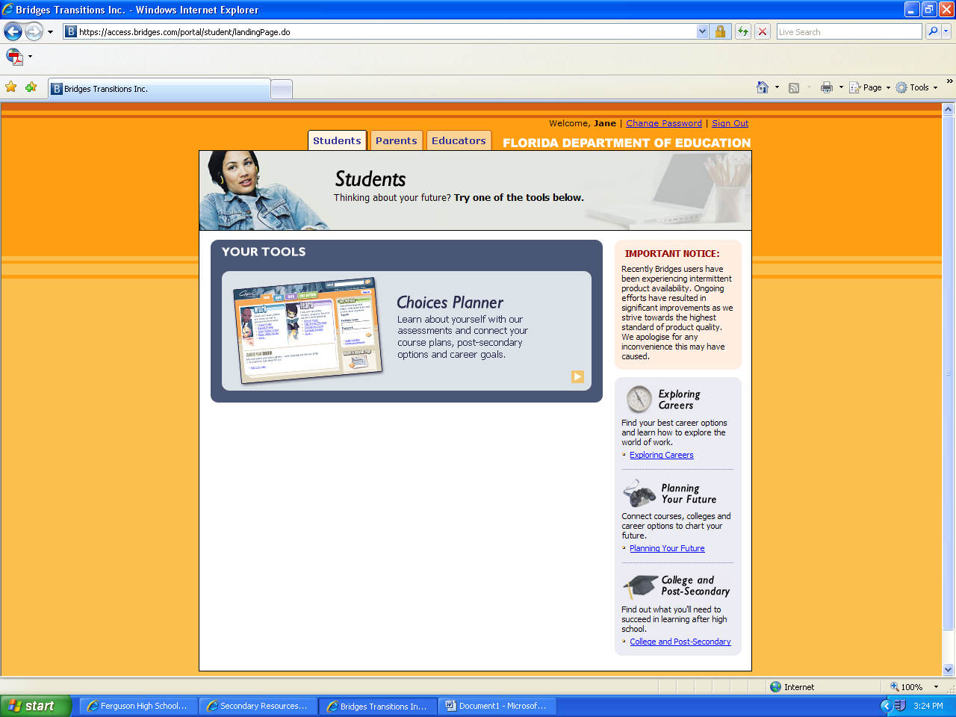
- Select “Interest Profiler”
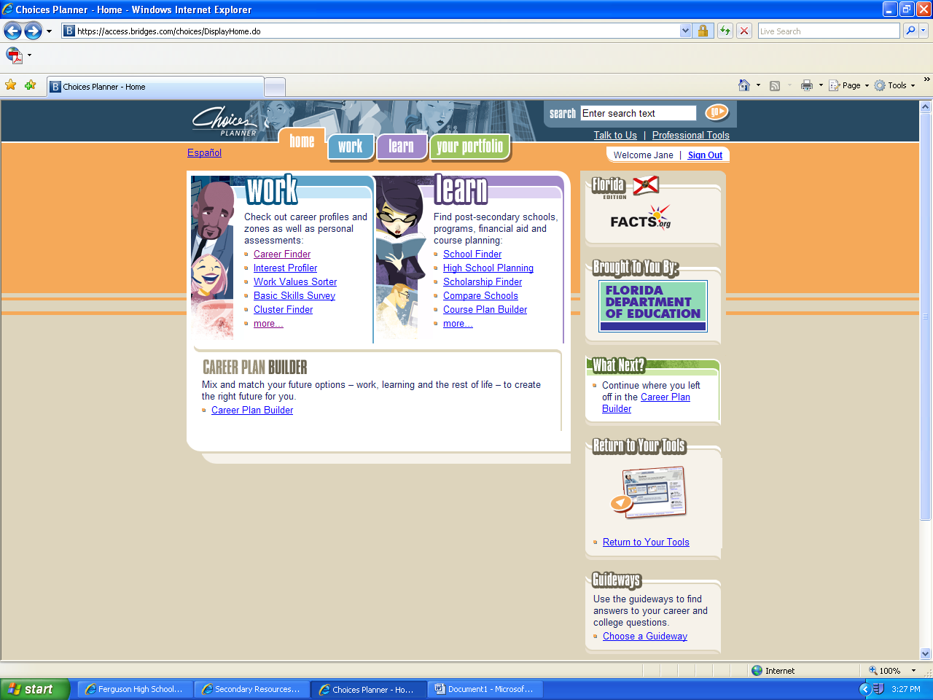
- Begin answering the questions.
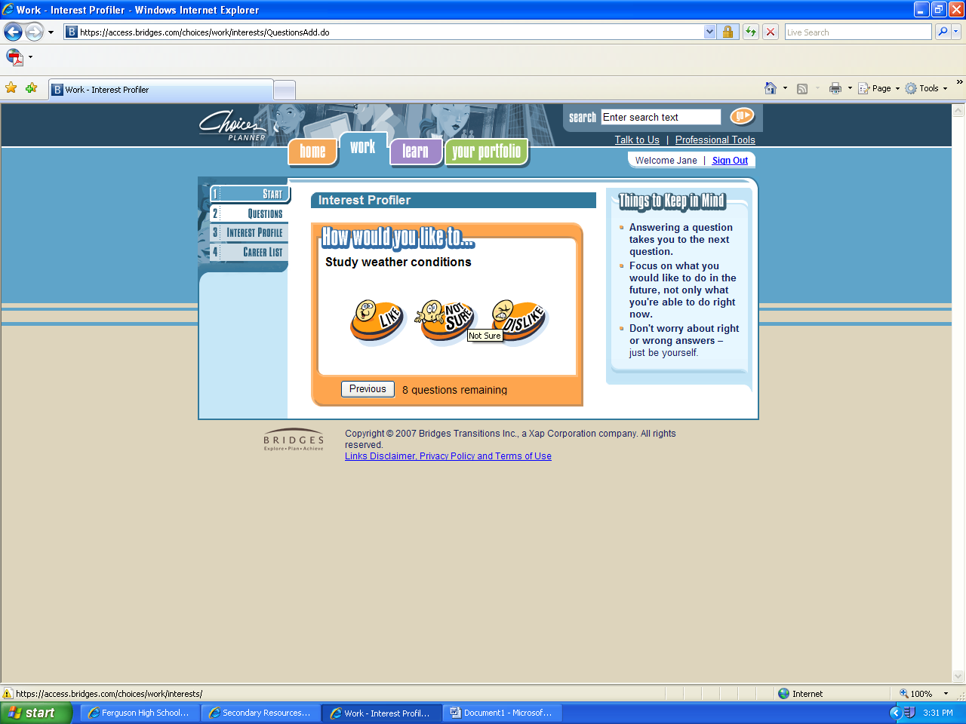
- When you finish answering all the questions, the profiler will summarize your results and recommend careers that match your interest based on the answers you provided. Click on “check out careers matching your interests”
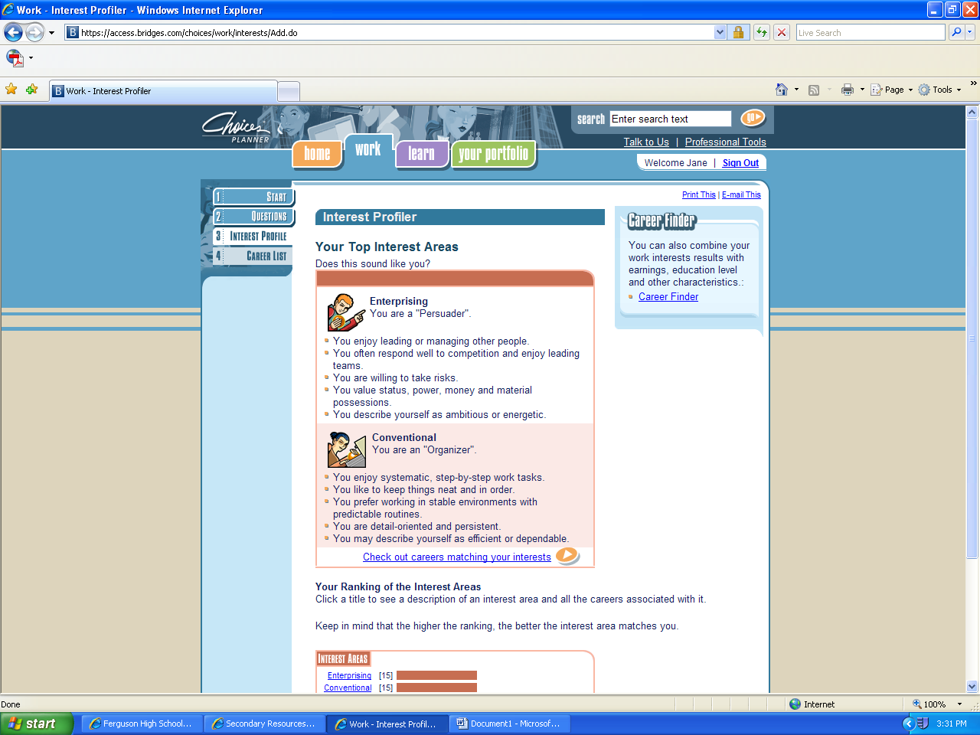
12. Select a career that interests you from the recommended list
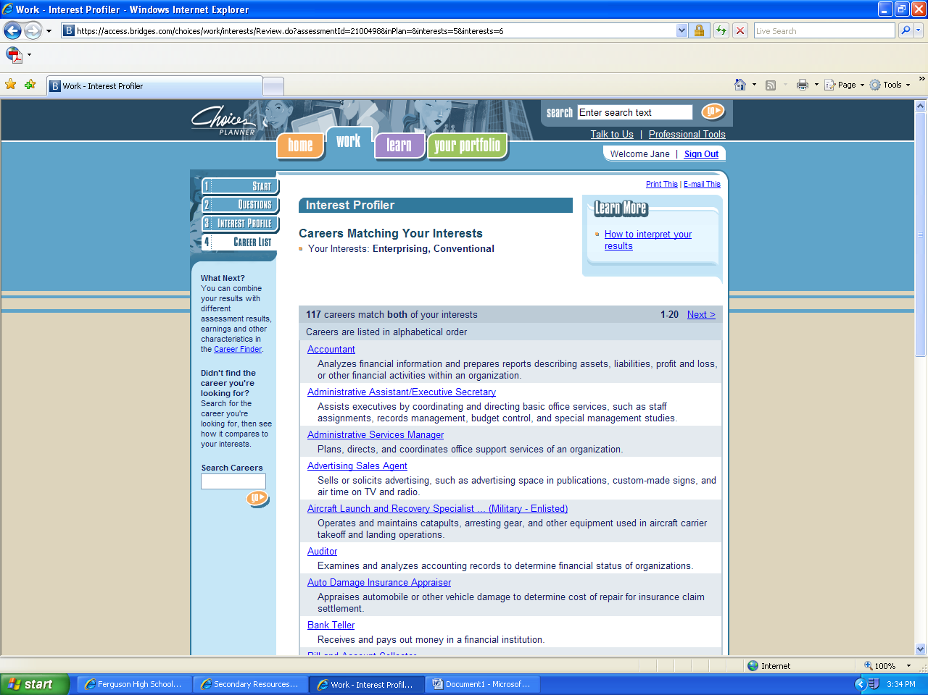

Get information on the following topics:
- Description of career:

- Field of work:

- Career pathways and clusters:

- Specialties and similar occupations:

- Education, training, and work experience:

- Basic skills needed:

- General workplace skills

- Suggested school courses:

- Aptitudes:

- Career areas:

- Work values:

- Interest:

- Myers-Briggs types:

- National Employment and Outlook:

- National earnings:

- Florida earnings:

- Physical demands:

- Physical abilities:

- Work conditions:

- Work hours and travel:

