**John A. Ferguson Senior High School Parent/Student Handbook**

**2012-2013**



**John A. Ferguson Senior High**

**Dr. Lisa Robertson, Principal**

**Miami-Dade County Public Schools**

**The School Board of Miami-Dade County, Florida**

**Ms. Perla Tabares Hantman, Chair**

**Dr. Lawrence S. Feldman, Vice Chair**

**Dr. Dorothy Bendross-Mindingall**

**Mr. Carlos Curbelo**

**Mr. Renier Diaz de la Portilla**

**Dr. Wilbert "Tee" Holloway**

**Dr. Martin Karp**

**Dr. Marta Pérez,**

**Ms. Raquel A. Regalado**

**Mr. Jude Bruno, Student Advisor**

**Mr. Alberto M. Carvalho**

**Superintendent of Schools**

**Mr. Freddie Woodson**

**Deputy Superintendent, District/School Operations**

**Miami-Dade County Public Schools**

**Vision Statement**

*We are committed to provide educational excellence for all.*

**Mission Statement**

*We provide the highest quality education so that all of our students are empowered to lead productive and fulfilling lives as lifelong learners and responsible citizens.*

**Message from the Principal**

Dear Parents and Students,

Welcome to John A. Ferguson Senior High School. I hope you had an enjoyable and productive summer vacation and are ready to begin the 2012 – 2013 school year. John A. Ferguson Senior High School enjoys a positive reputation as well as outstanding academic achievements. It is our hope that, as a family of administrators, faculty, staff and students, we can work together to continue the tradition of excellence.

Ferguson is an Academy Senior High school that leads the way in the District in the Secondary School Reform initiative. As part of SSR, Ferguson offers an eight period day, an alternating 4 x 4 block schedule. As part of the academy structure, you will become part of a small learning community sharing the same administrator, lead teacher and counselor while providing you with a rigorous curriculum designed to help achieve both your academic and career goals.

Additionally, it is recommended that you get involved in both athletic and extracurricular activities. Ferguson offers a large compliment of interscholastic teams and numerous clubs and organizations. While academics are a priority at Ferguson, participation in extracurricular opportunities helps develop a well-rounded educational experience.

The administration, faculty and staff at John A. Ferguson Senior High School are dedicated and hardworking educators. Our goal is for you to be successful. Believe in yourself, reach out for help when you need it and always remember “No Goal’s Too High Where Falcons Fly”!

Sincerely,

Dr. Lisa Robertson

Principal

**John A Ferguson Senior High**

**Mission Statement**

The mission of John A. Ferguson Senior High School is to develop within its community the actualization of the essential core values. These are:

*Integrity*

*Visionary Leadership*

*Lifetime Learning*

*Pursuit of Excellence*

*Respect*

*Responsibility for Self and Community*

**Alma Mater**

Hail to thee, our Alma Mater,

Ever loyal, brave and true;

Lead us on in truth and honor

In the paths that we pursue.

Rising up to every challenge,

May we keep our goals so high.

Forever we will honor thee:

Hail to Ferguson High!

**School Colors**

Black, Silver, and White

**School Mascot**

**Falcons**

**School Motto**

***“No Goal’s Too High Where Falcons Fly!”***

**Website**

[**http://ferguson.dadeschools.net**](http://ferguson.dadeschools.net)

**Reverend John A. Ferguson**

Reverend John Alphonso Ferguson was born on July 23, 1923 in Miami, Florida. He graduated from Carver Senior High in 1941 and served with the U.S. Navy for 21 years. Reverend Ferguson is a graduate of Union Theological Seminary and Virginia Union University. He and his wife, Anita, have five children.

For 31 years, Reverend Ferguson dedicated himself to the Second Baptist Church in Richmond Heights, which he founded in 1964. He has worked to unite the multi-cultural population and helped keep the peace during the Liberty City riots of the 1980s. He also served on the School Desegregation Committee and assisted with the desegregation of all local public schools.

On August 23, 2000, the Miami-Dade County Public School Board voted to name the new high school John A. Ferguson Senior High School in Reverend Ferguson’s honor. John A. Ferguson Senior High School was officially dedicated on April 22, 2004.

In July of 2012, our school’s namesake Reverend Ferguson passed away.

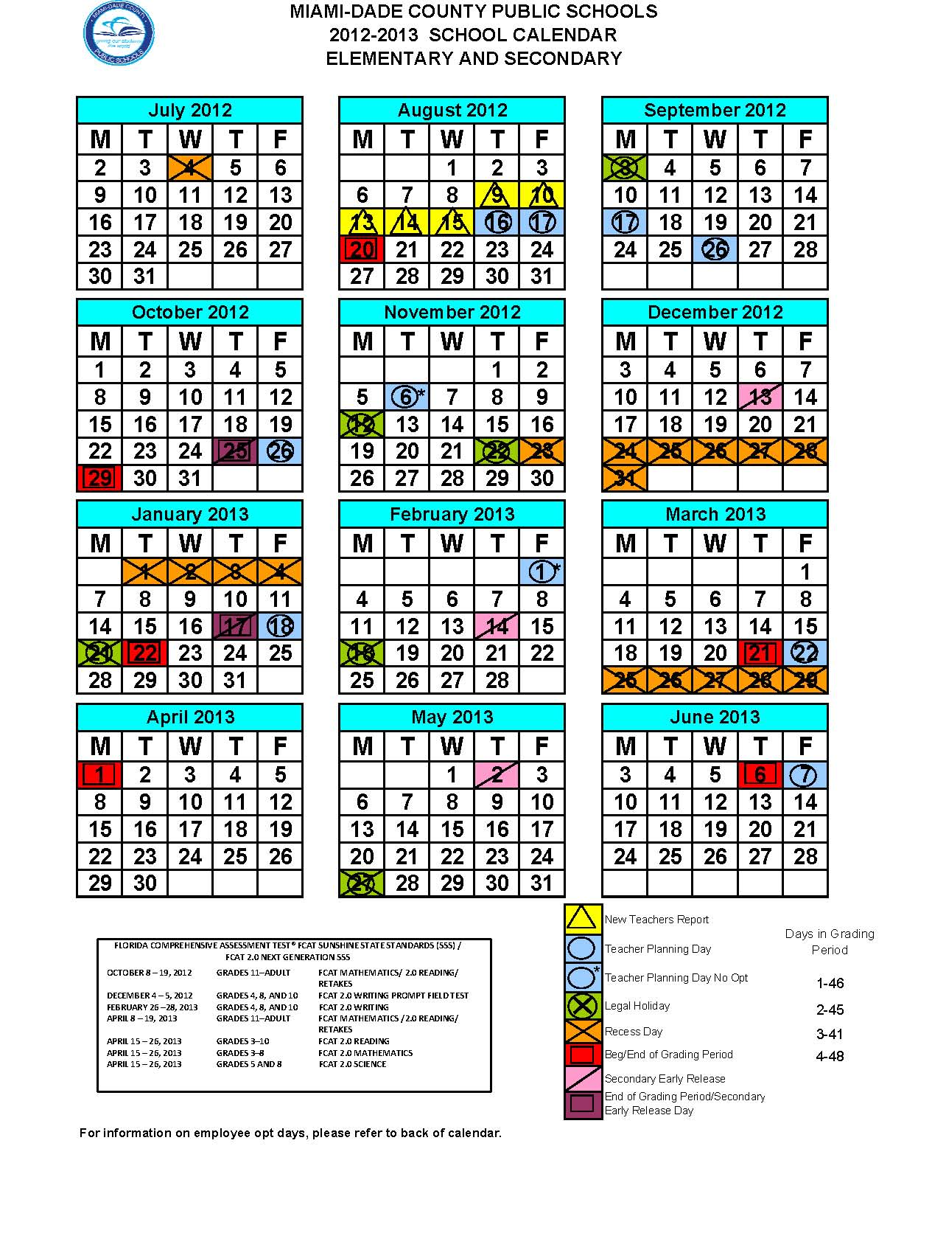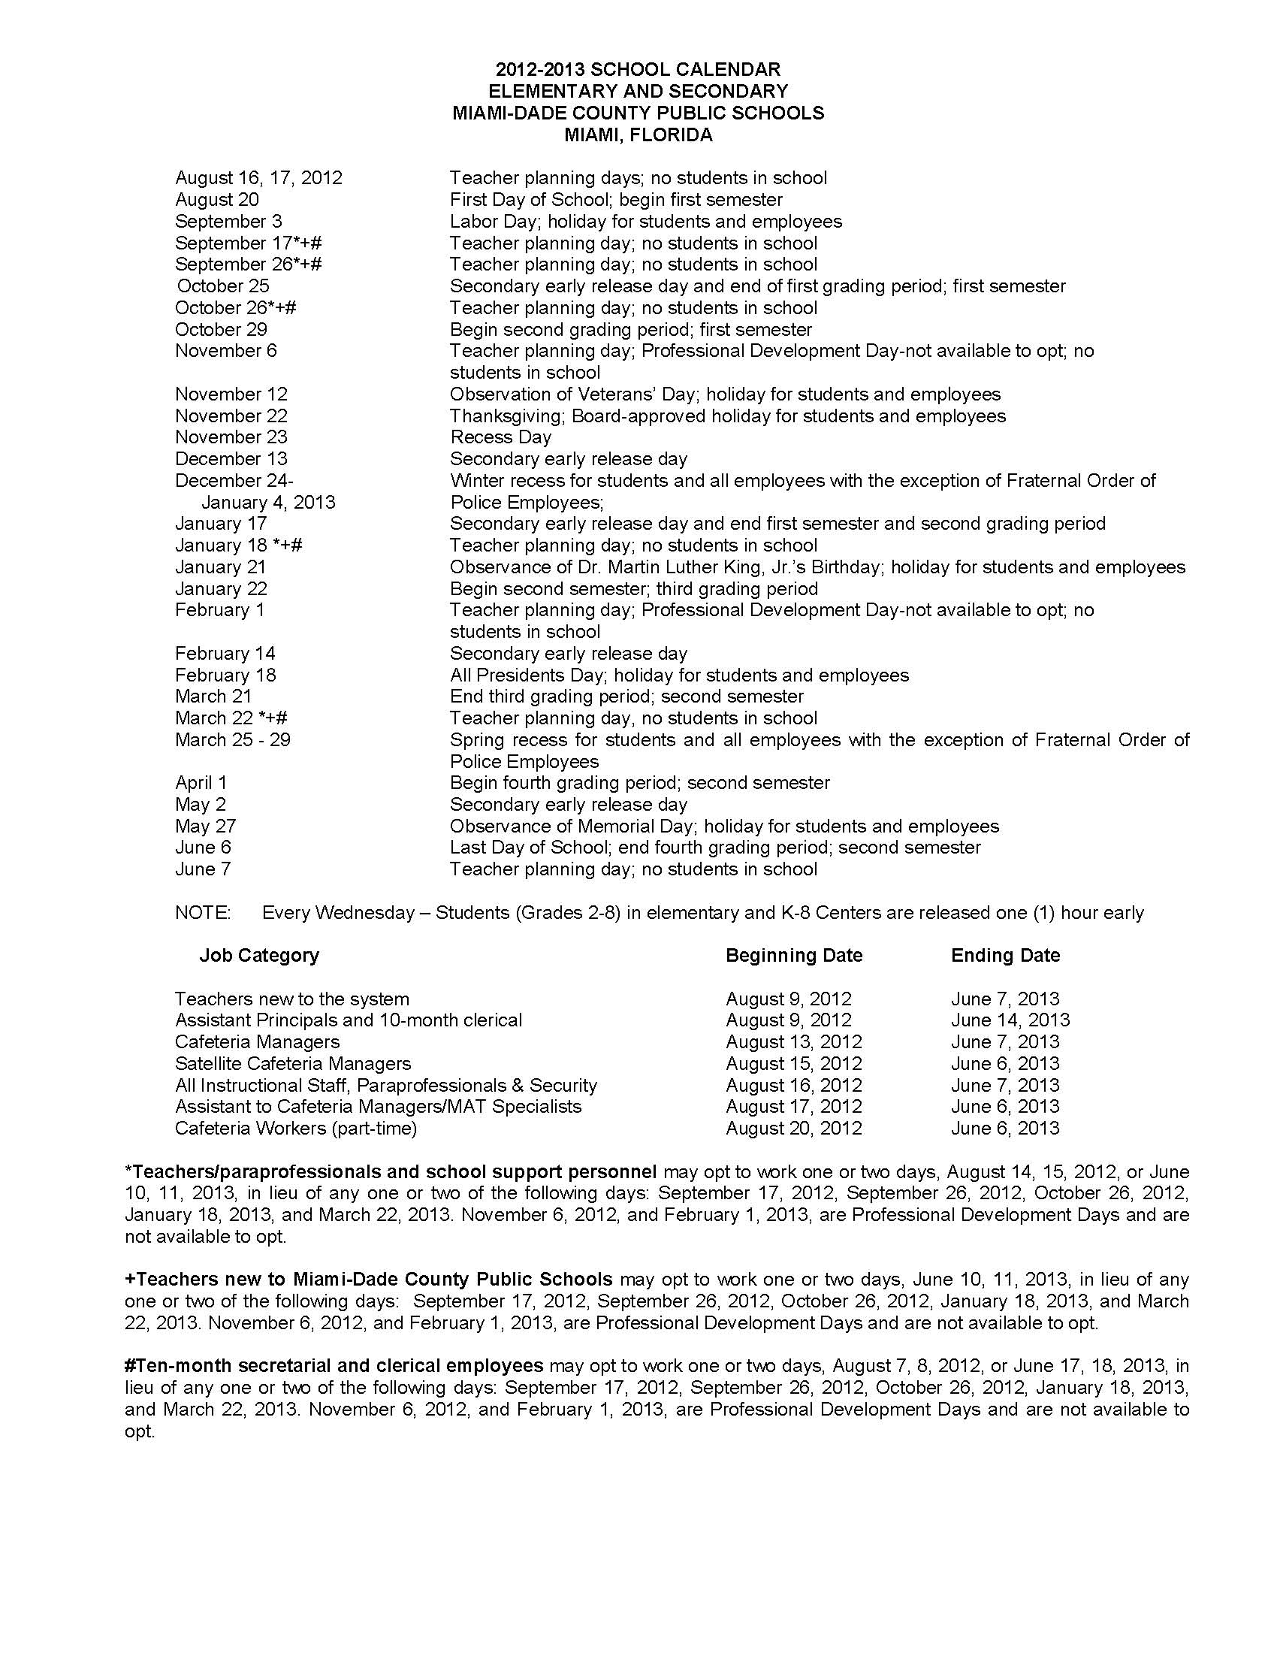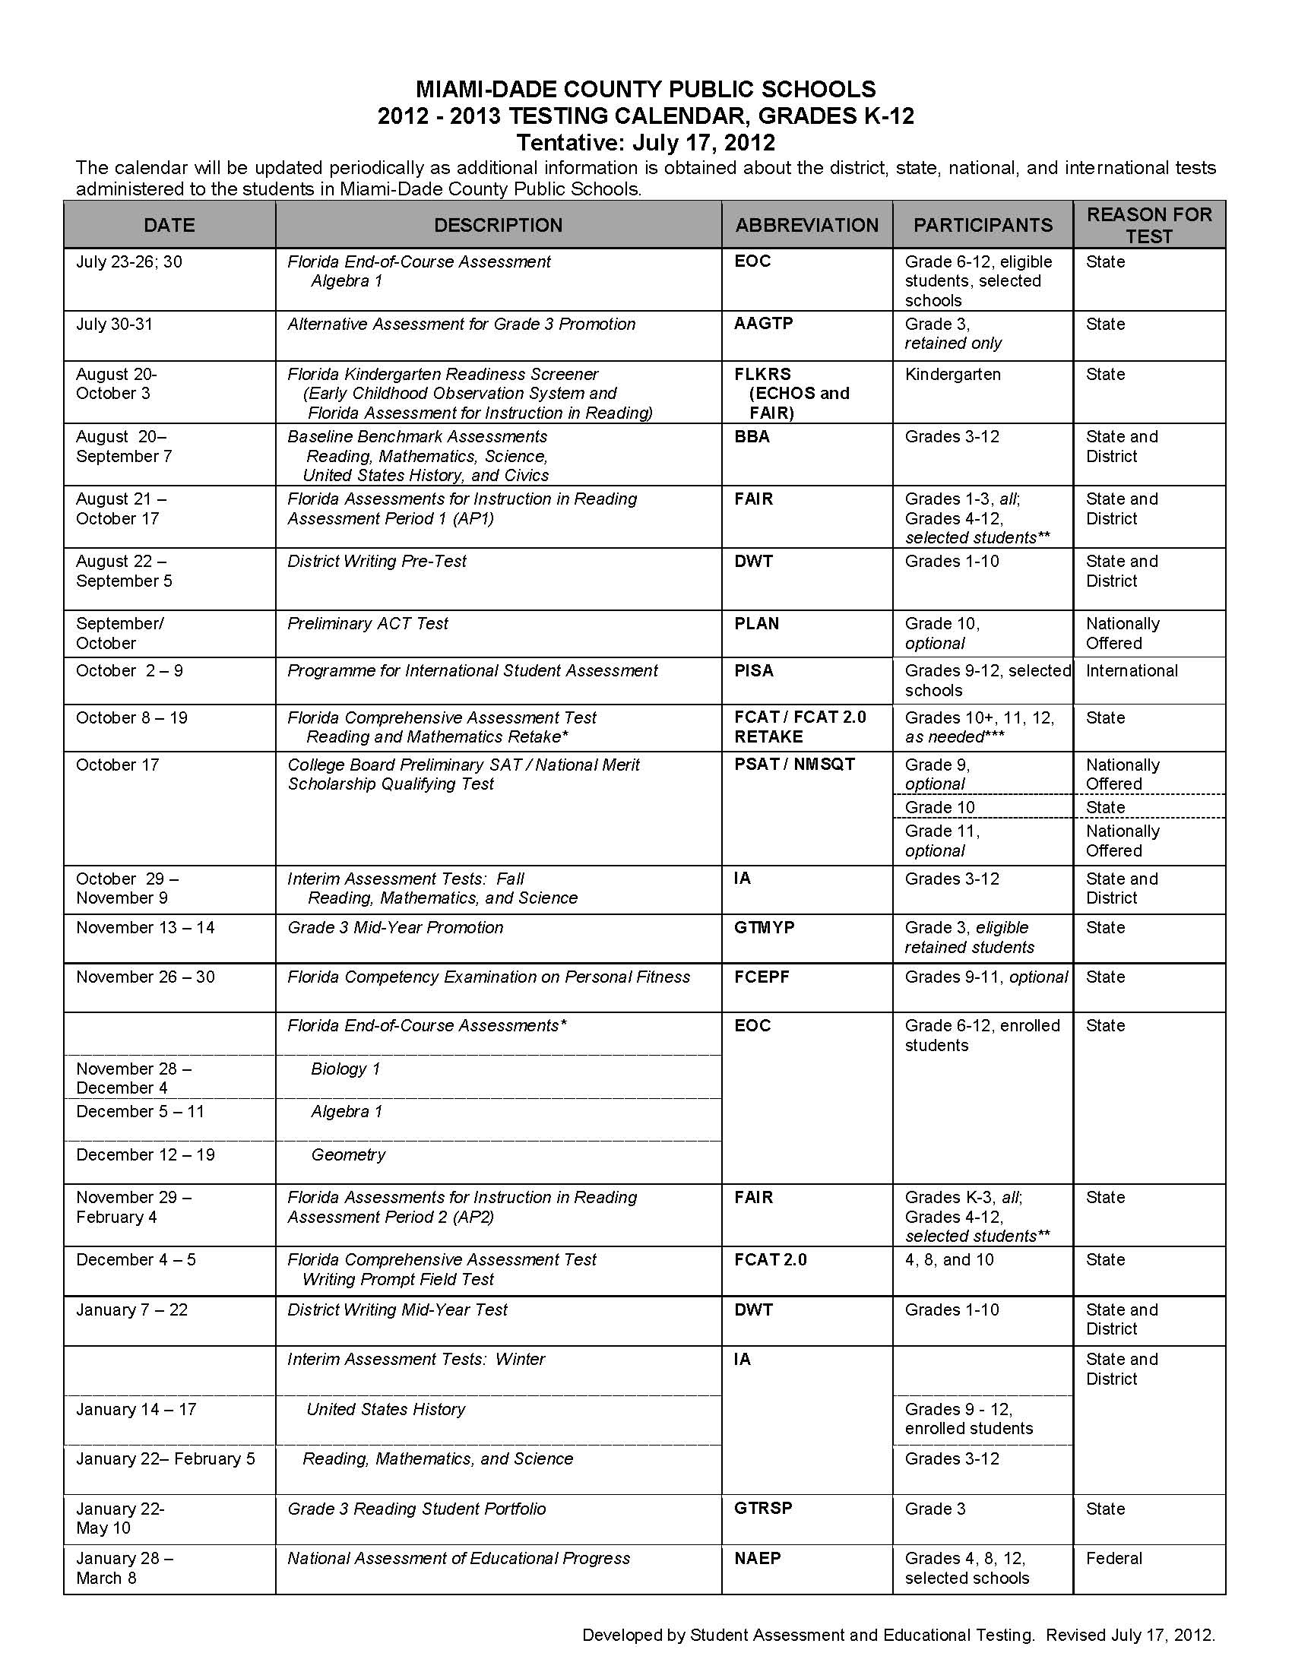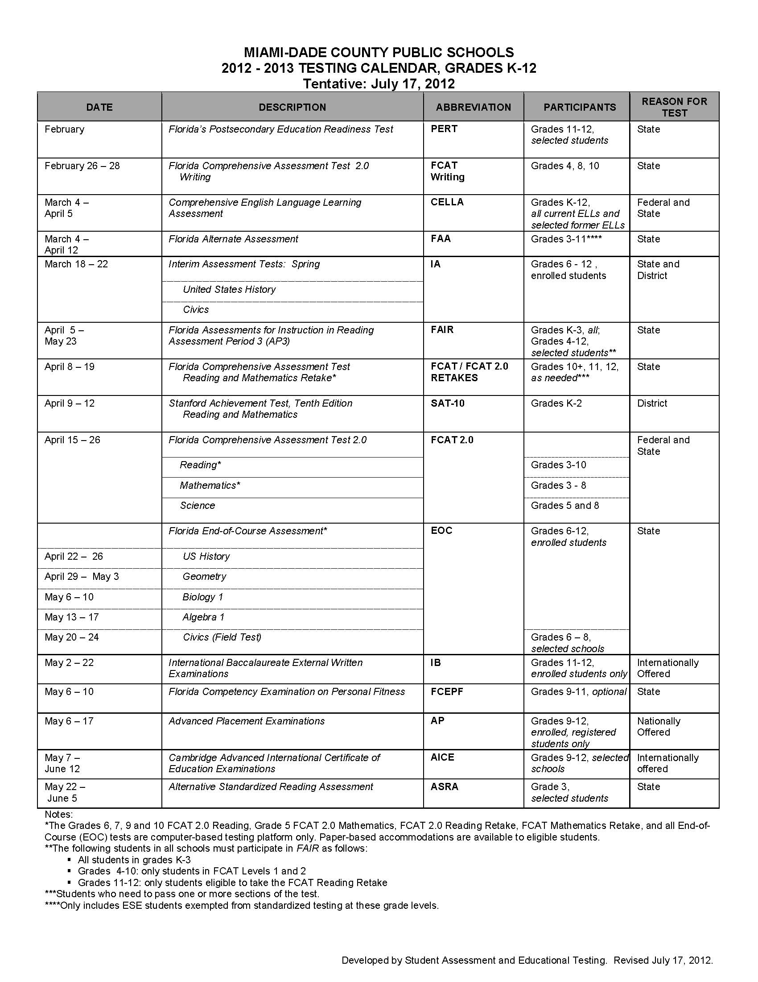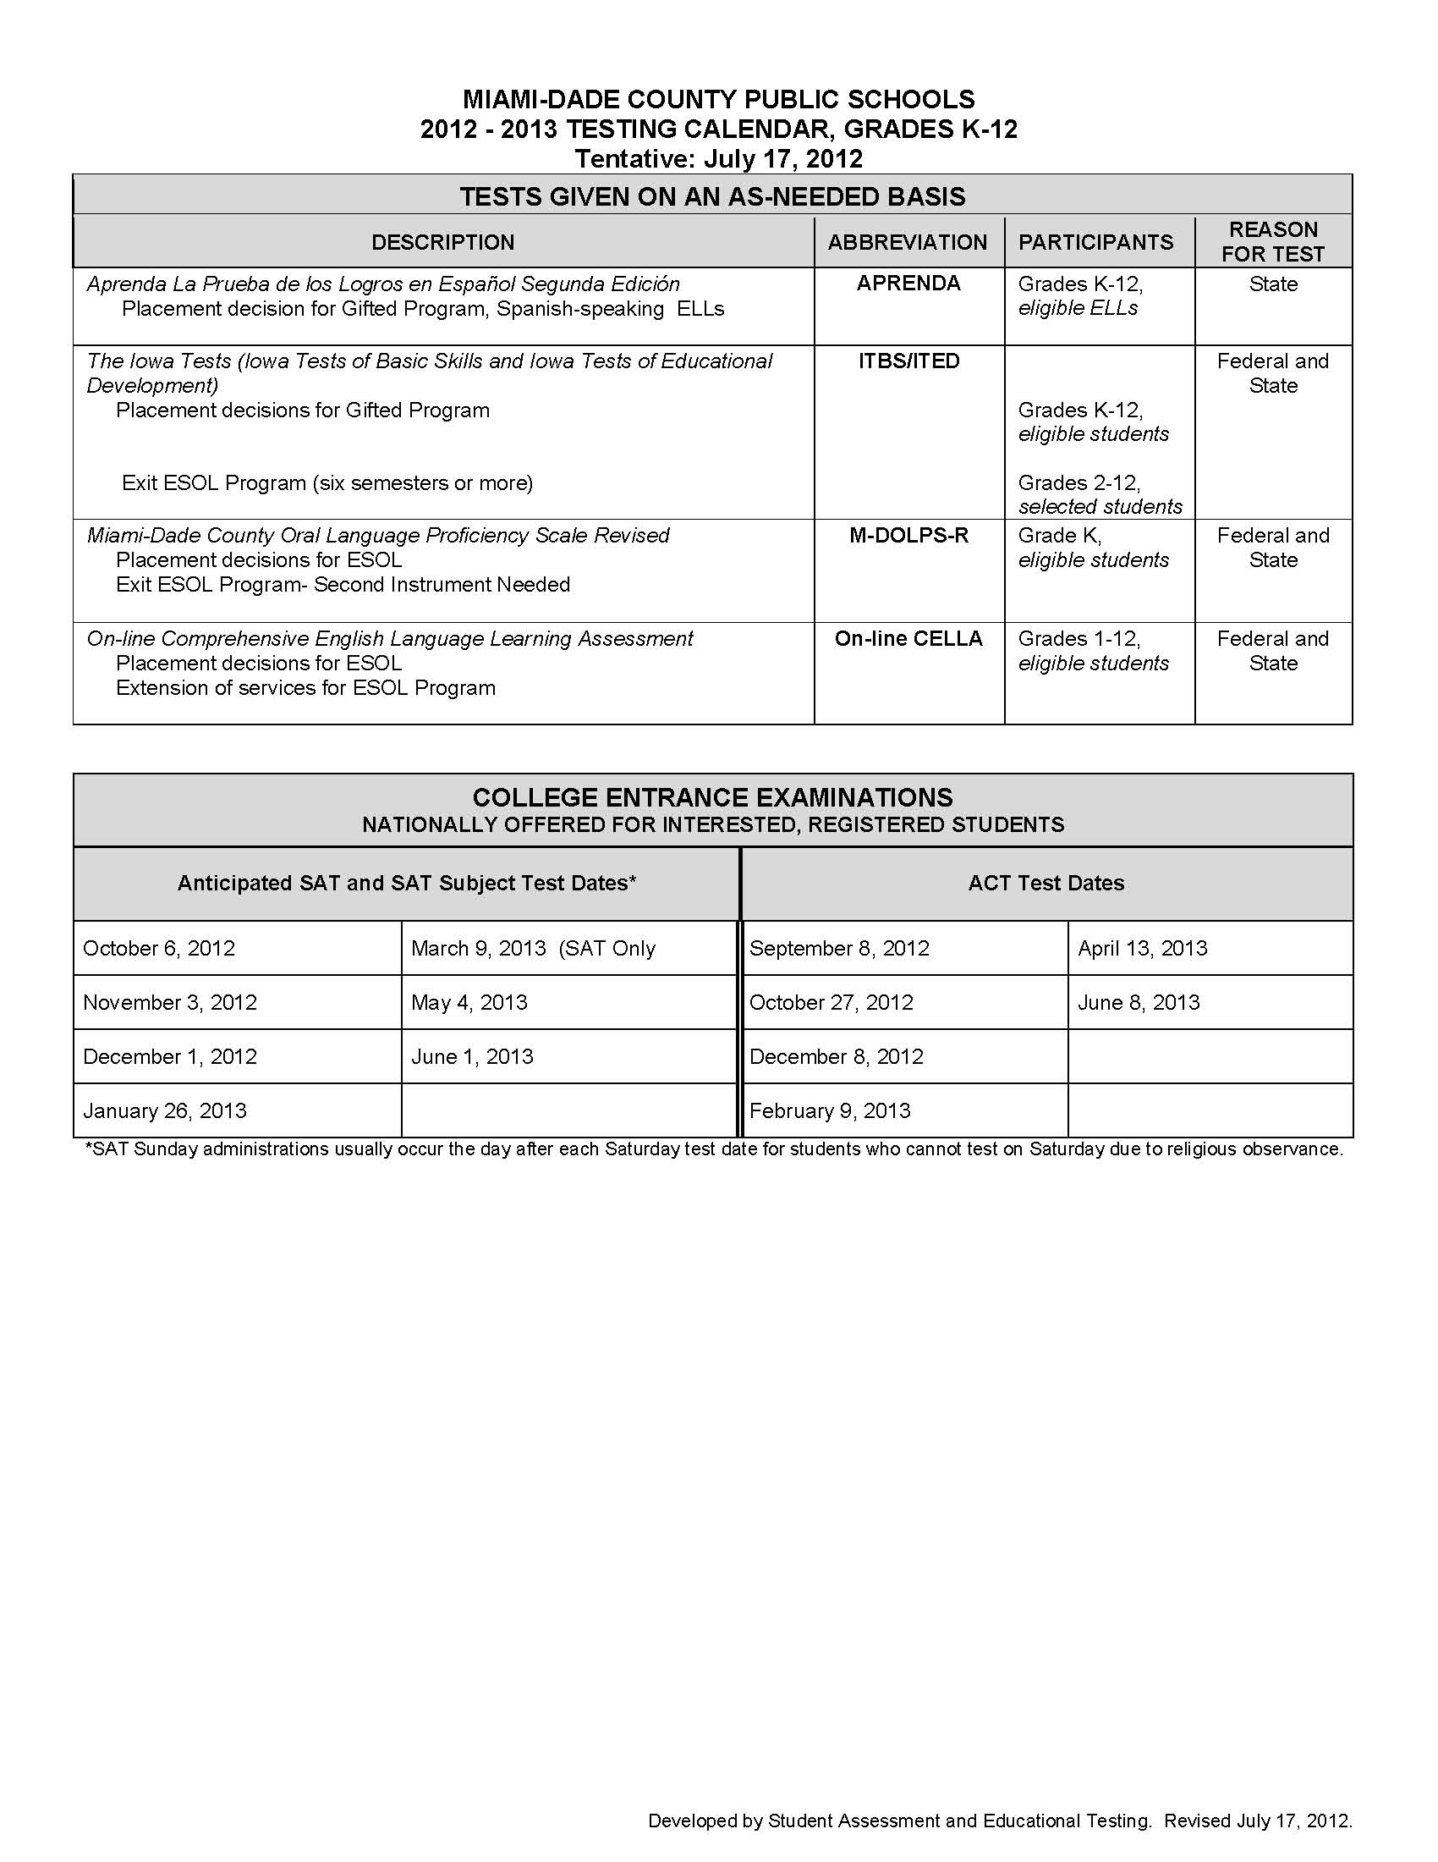



**Important Dates - Tentative**

|  |  |
| --- | --- |
| **Interim Report Distribution** | **Report Card Distribution** |
| September 21, 2012 | November 16, 2012 |
| December 4, 2012 | February 8, 2013 |
| February 20, 2013 | April 18, 2013 |
| May 2, 2013 | June 27, 2013 |

**Activities**

***Clubs***

Miami-Dade County Public Schools’ students may participate in a wide variety of activities, including student council, subject-area clubs, honor societies, service clubs, school publications and class activities. School-sponsored clubs may be curriculum-related or noncurriculum-related.

Curriculum-related clubs are student groups whose goals are an extension of the activities and objectives in a particular subject area within the school's curriculum. Conversely, noncurriculum-related clubs are student groups whose goals are special interest oriented and not directly related to the curriculum. Meetings of noncurriculum-related clubs may be scheduled only at times when instruction is not taking place, either before or after school.

***Fieldtrips and Special Activities***

Participation in fieldtrips requires that the student present a fieldtrip form signed by the parent/guardian to his/her teacher(s) in advance. In addition, at times vendors who have a “no refund” policy will require schools to pay the full amount of the fieldtrip prior to the event. In this case, students/parents will be notified in advance of the vendor’s “no refund” policy.

***Parties in School***

Birthday parties are not allowed.

**Fundraisers – Board Policy 5830**

Fundraising activities must be conducted during non-instructional class time, preferably before and after school. An *Application for Fundraising Activity*, M-DCPS Form 1018 must be completed. Regional Center approval is required for any fundraising activity where collections take place outside of school grounds. This approval can be obtained by completing M-DCPS Form 5656, *Region Center Approval for Fundraising Activity (Community Sales).*

Fundraising activities involving students working or providing services for community events or outside business organization for which compensation, monetary or otherwise, will be given, either to the students or the school, **are not** allowed to be conducted as school-sponsored /student fundraisers. Elementary school students are not allowed to participate in the sale of magazines.

**Athletics**

Eligibility/Student Contracts

Any student interested in participating in interscholastic sports must purchase school/football insurance prior to participation at any level. Additional information on the school’s athletic programs may be obtained from the Athletic Director.

A student is eligible to participate in interscholastic sports if he/she:

* undergoes a physical evaluation yearly, no earlier than June 1
* presents an original birth certificate
* has a cumulative high school grade point average of 2.0 or above on a 4.0 unweighted scale
* is in ninth grade and was regularly promoted from the eighth grade the immediate preceding year
* adheres to the principles of good sportsmanship and the ethics of competition at all times

Students will be declared ineligible:

* By the principal for not meeting & upholding the requirements of the “Contract for Student Participation in Interscholastic Competitions or Performances”.
* After four (4) consecutive academic years from the date he or she first enrolls in the ninth (9th) grade
* Upon reaching the age of 19 years 9 months

**Attendance Policy – Board Policy 5200**

Student attendance is a means of improving student performance and critical in raising student achievement. Together, the staff of Miami-Dade County Public Schools, students, parents and the community must make every effort to lessen the loss of instructional time to students.

***Excused School and Class Absences and Tardies***

* + - 1. Student illness: Students missing 5 or more consecutive days of school due to illness or injury are required to provide a written statement from a health care provider. The written statement must include all days the student has been absent from school. If a student is continually sick and repeatedly absent from school due to a specific medical condition, he or she must be under the supervision of a health care provider in order to receive excused absences from school.
      2. Medical appointment: If a student is absent from school due to a medical appointment, a written statement from a health care provider indicating the date and time of the appointment, must be submitted to the principal.
      3. Death in immediate family
      4. Observance of a religious holiday or service when it is mandated for all members of a faith that such a holiday or service is observed.
      5. School-sponsored event or educational enrichment activity that is not a school-sponsored event, as determined and approved by the principal or principal’s designee: The student must receive advance written permission from the principal or the principal’s designee. Examples of special events include: public functions, conferences, and region, state and national competitions.
      6. Subpoena by law enforcement agency or mandatory court appearance.
      7. Outdoor suspensions
      8. Other individual student absences beyond the control of the parent/guardian or student, as determined and approved by the principal or the principal's designee. The principal shall require documentation related to the condition.

***Unexcused School Absence***

Any absence that does not fall into one of the above excused absence categories is to be considered unexcused. Any student who has been absent from school will be marked unexcused until he/she submits required documentation as specified above. Failure to provide required documentation within three school days upon the return to school will result in an unexcused absence. Unexcused absences include:

1. Absences due to vacations, personal services, local non-school event, program or sporting activity

2. Absences due to older students providing day care services for siblings

3. Absences due to illness of others

4. Absences due to non-compliance with immunization requirements (unless lawfully exempted)

**Bringing Pets to School**

Students are not allowed to bring pets to school.

**Arrival/Dismissal**

***School Hours***: Customize

***Bell Schedule*** *–*

7:20 - 9:00 BLOCK 1 – PERIOD 1/2 & Homeroom

9:05 - 10:35 BLOCK 2 – PERIOD 3/4

10:40 - 12:45 BLOCK 3 – PERIOD 5/6

**11:15 - 11:50 LUNCH 1 Rooms 50–75; 101-368**

**12:10 - 12:45 LUNCH 2 Rooms 412-808 & AUD; 1001-1060; 1201-1260**

12:50 - 2:20 BLOCK 4 – PERIOD 7/8

***Late Arrival***

Students who are tardy to school must get a pass before reporting to class students that are tardy before 7:40 AM are to get a PLASCO pass at the auditorium window or at a designated PLASCO location. After 7:40, students must report to the Attendance Office to secure an admit. Excessive tardies may result in loss of privileges, detention, parent conference, and/or suspension. Late arrivals may be accrued and count towards unexcused absences.

***Early Sign Out- Board Policy 5200***

The early release of students causes disruption to the academic performance of all students and may create safety and security concerns. No students shall be released within the final 30 minutes of the school day unless authorized by the principal or principal’s designee (i.e., emergency, sickness). No one will be allowed to sign out after 1:50 PM.

**Comprehensive Reading Plan**

Elementary students are required to read at least five books or their equivalent during each nine-week grading period, including in-class independent reading and at-home reading. Students must also read for 30 minutes at home as part of their daily homework assignment. The length of the books and the complexity of the content may be taken into account when satisfying this requirement.

**Cafeteria**

***Food Cost***

Breakfast

All Students No charge

Adults $2.00

Lunch

Elementary Students $2.25

Secondary Students $2.50

Reduced Price, Students $0.40

Adults and non-students $3.00

***Free Breakfast***

The National School Breakfast Program was enacted to ensure that school children are being served a nutritious breakfast daily. **Miami-Dade County Public Schools offers breakfast at no charge to all M-DCPS Students**. The breakfast at no charge is not dependent on the student qualifying for free/reduced meals at lunch.

***Free/Reduced Lunch Program***

The National School Lunch and School Breakfast Programs as administered by Miami-Dade County Public Schools provide free and reduced priced meals for children unable to pay the full price. Applications must be filled out every school year; forms are sent to all homes with a letter to parents or guardians the first week of school. Meal benefits begin on the day the application is approved and continue throughout the school year in which the application is approved, the summer, and approximately **the first twenty days of the next school year**.

***PAYPAMS***

Miami Dade County Public School’s Department of Food and Nutrition allows parents/guardians the convenience to pay on-line via the internet or by telephone for their child’s/children meals with a credit or debit card. The parent/guardians will create a lunch account on-line for the child and will be able to access the following:

a. view the account balance

b. schedule automatic payments

c. receive low-balance e-mail reminders

d. view a report of daily spending and cafeteria purchases

***Cafeteria Rules***

* Keep in a single line
* Always be courteous to the cafeteria workers
* Always use acceptable table manners
* Discard the trash appropriately

**Confidential Information**

Parents, guardians and students are protected by The Family Educational Rights and Privacy Act and the Florida Statutes from individuals’ access to information in students’ educational records, and are provided the right to challenge the accuracy of these records. These laws provide that without the prior consent of the parent, guardian or eligible student, a student's records may not be released, except in accordance with the provisions listed in the above-cited laws. The laws provide certain exceptions to the prior consent requirement to the release of student records, which include, but are not limited to, school officials with a legitimate educational interest and lawfully issued subpoenas and court orders.

Each school must provide to the parents, guardians or eligible students annual notice in writing of their right to inspect and review student records. Once a student reaches 18 years of age or is attending an institution of post-secondary education, the consent is required from the student only, unless the student qualifies as a dependent under the law.

**Parent-Teacher Association (PTA/PTSA)**

The John A. Ferguson Senior High Parent-Teacher Association works with state and national PTAs to support and speak in the schools, in the community and before governmental bodies and other organizations that make decisions affecting youngsters. We support the faculty and administration in their efforts to improve educational and extracurricular activities in the school. We work to encourage parent, student and public involvement at the school as a whole.

**Emergency Contact Information**

Student Data/Emergency Contact Cards are distributed during the first week of school. Students are expected to bring the cards home and present them to their parents or guardians. The card must be carefully completed and then returned. The information provided on the Student Data/Emergency Contact Card will enable school staff to contact the parent/guardian immediately in the case of an emergency. Students may only be released from school to the persons listed on the emergency contact card after presenting a picture identification. No persons, other than school staff, will have access to the information submitted.

**Halls/Hall Passes**

Students should be seated in their classroom when the tardy bell rings. With such a large number of students moving in such a limited time, it is incumbent on each person to move quickly and in an orderly manner observing normal traffic flow. Please do not push, run or loiter in the halls. Please cooperate with the Hall Monitors in the exercise of their duties and present a hall pass courteously when asked to do so.

At no time is a student to be out of the classroom during class without an official Yellow Pass. Teachers are not to give verbal permission for a student to exit the classroom.

**Code of Student Conduct**

Miami-Dade County Public Schools (M-DCPS) is committed to providing a safe teaching and learning environment for students, staff, and members of the community. On March 12, 2008, the School Board approved a newly revised Code of Student Conduct (COSC). The revised COSC identifies, recognizes, and rewards model student behavior within a framework of clearly established and enforceable rules and policies. It advocates a holistic approach to promoting and maintaining a safe learning environment and requires active participation from students, parents/guardians, and school staff. Students and parents/guardians can access the English, Haitian/Creole and Spanish versions of the document on the M-DCPS Website located at: <http://ehandbooks.dadeschools.net/policies/90/index.htm> or you may request a copy from your child’s school. The Spanish version of this document will be forthcoming.

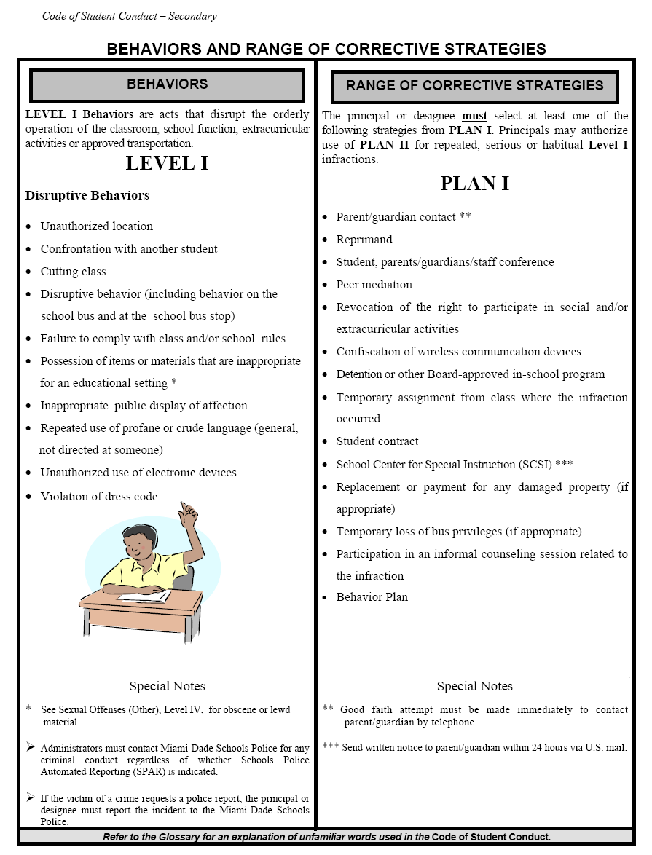

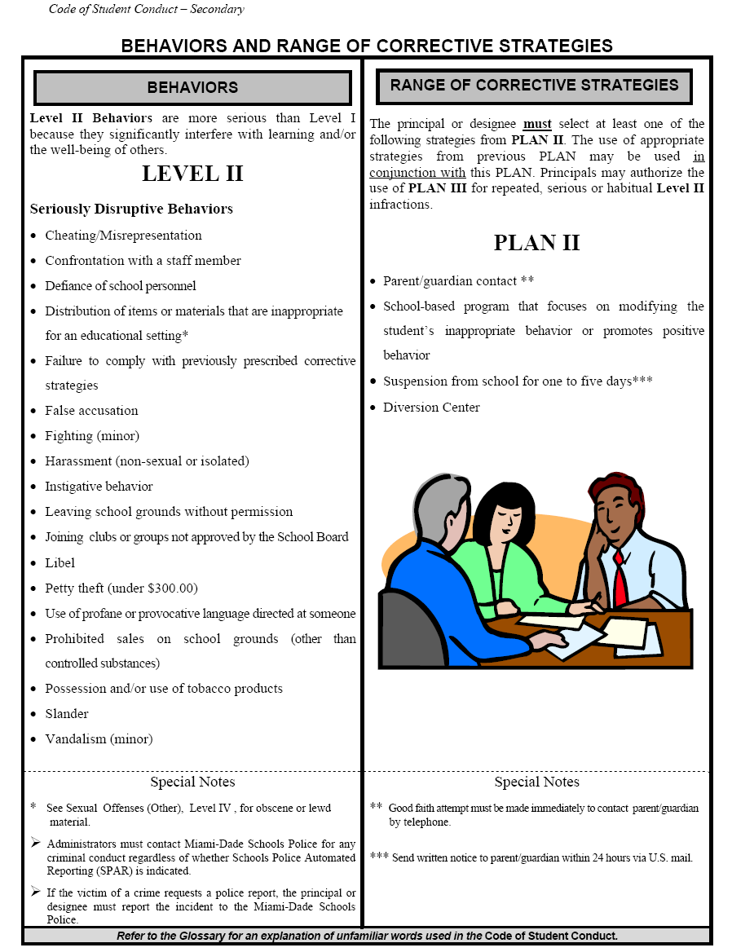

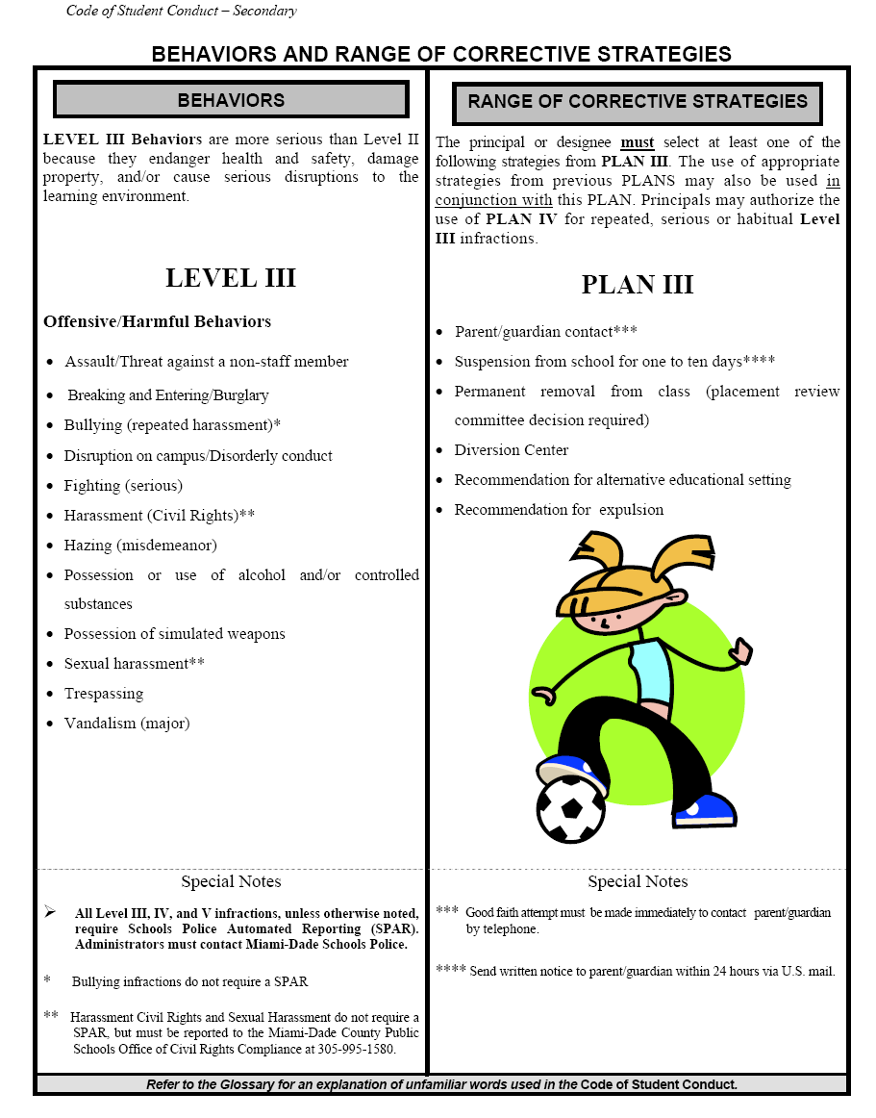

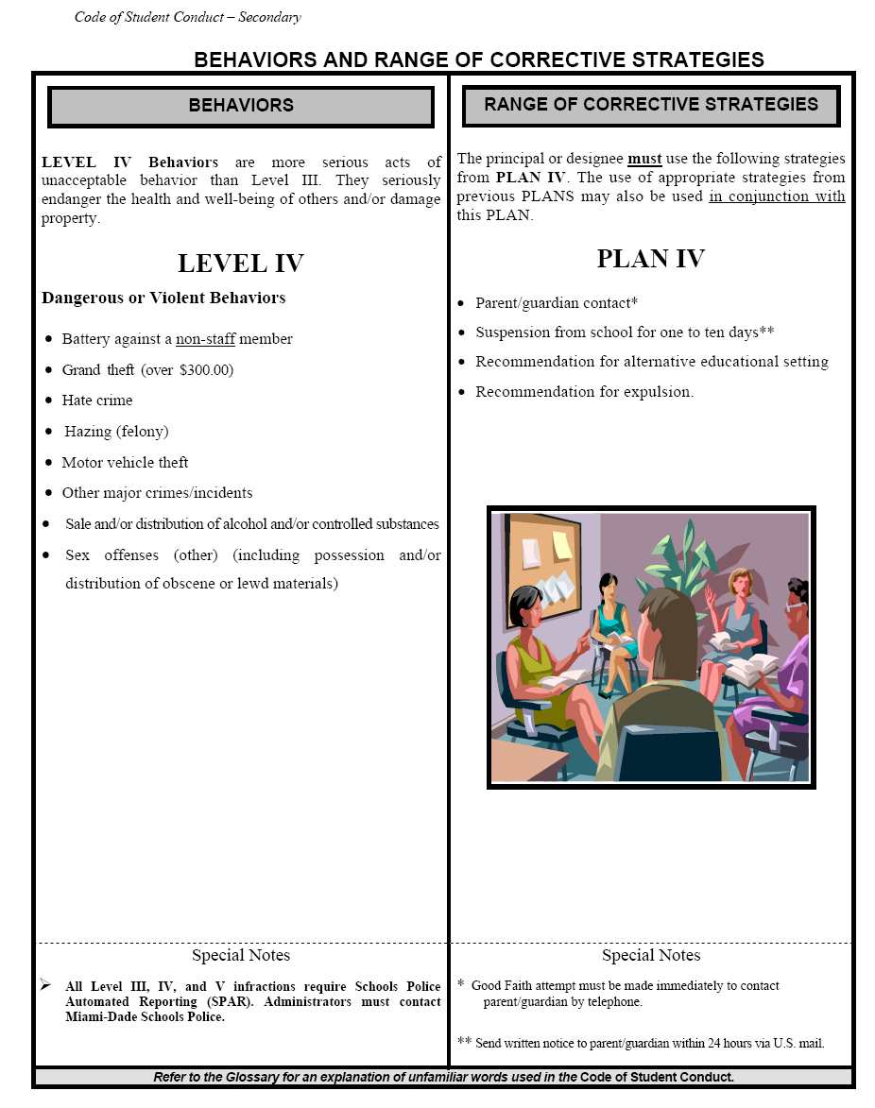

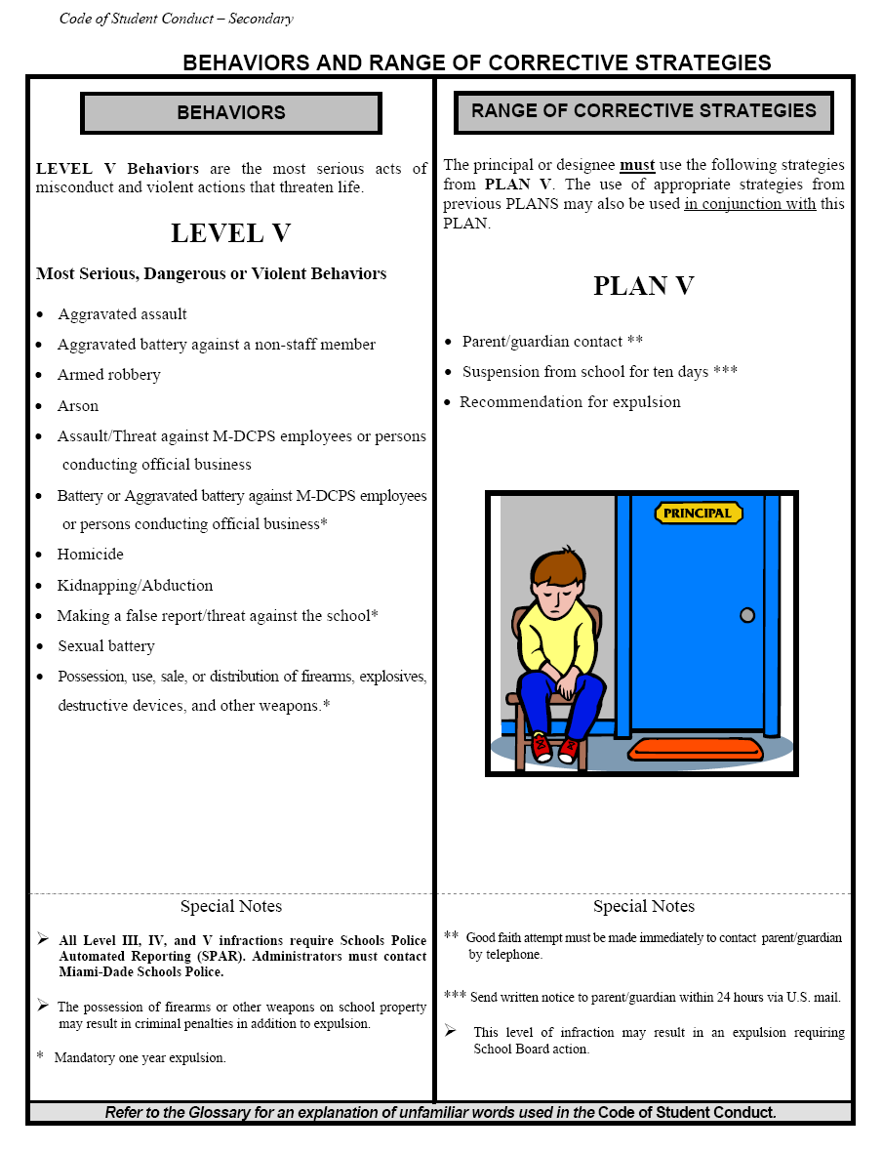

***Student Rights and Responsibilities***

The rights and responsibilities presented in the Code of Student Conduct reflect the need for providing students with greater opportunities to serve themselves and society, and allow students maximum freedom under law, commensurate with the schools' responsibility for student health, safety, and welfare.

***Dress Code*** *– Board Policy 5511*

Students are expected to come to school with proper attention having been given to personal cleanliness, grooming, and neatness of dress. Students whose personal attire or grooming distracts the attention of other students or teachers from their school work shall be required to make the necessary alterations to such attire or grooming before entering the classroom or be sent home by the principal to be properly prepared for school. Students who fail to meet the minimum acceptable standards of cleanliness and neatness as determined by the principal and as specified in this policy shall be subject to appropriate disciplinary measures.

***Uniform Policy***  All students are required to wear school uniforms at John Ferguson Senior High School. A safe and disciplined learning environment is the first requirement of an effective school. Students who are safe and secure, who learn basic values and the essentials of good citizenship, are better students. Parents, teachers, and school officials have come to see school uniforms as one positive and creative way to reduce discipline problems and increase school safety.

The potential benefits of school uniforms include:

•        Helping students concentrate on their school work;

•        Helping school officials to recognize intruders who come to school;

•        Helping parents and students resist peer pressure;

•        Increasing school safety by reducing incidents of bullying, theft, and violence;

•        Building school spirit by creating a sense of teamwork and togetherness.

All students are expected to wear their uniforms beginning the first day of the school year.

The following are acceptable uniforms:

* Black, khaki, or gray pants
* Black, white, or gray polo shirts
* Black, white, or gray button-down shirts

***Cell Phones***

Possession of a cellular telephone is not a violation of the Code of Student Conduct (COSC). However, the possession of a cellular telephone which disrupts the educational process; the use of the cellular telephone during school hours; and the possession or use of a cellular telephone which disrupts or interferes with the safety-to-life issue for students being transported on a M-DCPS school bus, would be a violation of the CSC.

***Internet Use Policy*** *– Board Policy 7540.03*

Access and use of the Internet is a privilege, not a right, and its use must support the educational objectives of the District. Students must always get permission from their teachers prior to using the internet. In addition, the District prohibits the transmission of materials such as copyright material, threatening or obscene material or material protected by trade secret, which violate local, state, and federal law or regulation, as well as the use of the Internet for product advertisement, commercial activities, political campaigning or solicitation.

**Health Screening**

Tuberculosis Clinical Screening - Each student shall have proof of a tuberculosis clinical screening and appropriate follow-up prior to initial enrollment in any grade in a Miami-Dade County Public School. This screening is to be administered at the time of the Student Health Exam and within twelve (12) months prior to initial enrollment in any grade in a Miami-Dade County Public School. If the screening indicates that a follow-up skin test is needed, a student can be admitted but only with a health provider's statement that the student is free of communicable tuberculosis and can attend school.

Scoliosis Screening (6th grade students – applies to K-8 centers) The Florida Legislature Statute, 381.0056 mandates scoliosis screenings to be performed annually for students in grade six. Consequently, your school has been scheduled to participate in the Scoliosis Screening Program sponsored by Miami-Dade County Public Schools and Easter Seals Miami-Dade. A sample letter ([**FM-4382**](http://comprehensivehealthservices.dadeschools.net/4382%20scoliosis.pdf)) notifying parents of the school’s scoliosis screenings to be performed should be reproduced and sent to parent(s)/guardian(s) of students as soon as possible. This screening will be performed by trained Easter Seals personnel on a specified date.

**Immunizations**

***Requirements for School Entry:***

1. a complete Florida Certification of Immunization – Blue Card Form DH 680 - according to grade level
2. State of Florida School Entry Health Exam – Yellow Form DH 3040 - no older than 12 months
3. Tuberculosis Clinical Screening, PPD or Chest X-ray.

**Insurance**

The Student Protection Plan is designed to cover students or injuries while traveling to and from school or when involved in accidents while engaged in supervised activities on the school premises. Participation in this program is voluntary. The school will forward the 2011-2012 enrollment application and additional information to the parents.

**Florida KidCare**

Florida KidCare provides high quality, low cost health insurance for uninsured children aged birth to 18.  KidCare includes MediKids, Healthy Kids, The Children's Medical Services Network (CMS) for children with special health care needs, and Medicaid.   
*Miami-Dade County Public Schools is a recipient of a Boots on the Ground School Partnership contract for marketing and outreach services.  In the coming weeks a variety of materials will be provided to schools to families to enroll their children in Florida KidCare. Go to [www.floridakidcare.org](http://www.floridakidcare.org/) for enrollment procedures.

**Parent Portal**

Parents/Guardians of all Miami-Dade County Public Schools students, including employees, have access to the Parent Portal. In order to access the information in the portal, you must first establish a parent user account. At this time you can see and update personal information, see his/her information - including grades, attendance, and bus route information, and have access to the *Parent Resource* link, which takes you to sites such as Parent Academy, School of Choice, etc.

You will also have access to electronic books for each subject; free and reduced lunch applications with balance renewal capability; access to a new *Choice* application that will allow parents to indicate preferential school choice via the portal; and access to the *Supplemental Educational Services (SES)* component of the No Child Left Behind Act (NCLB).

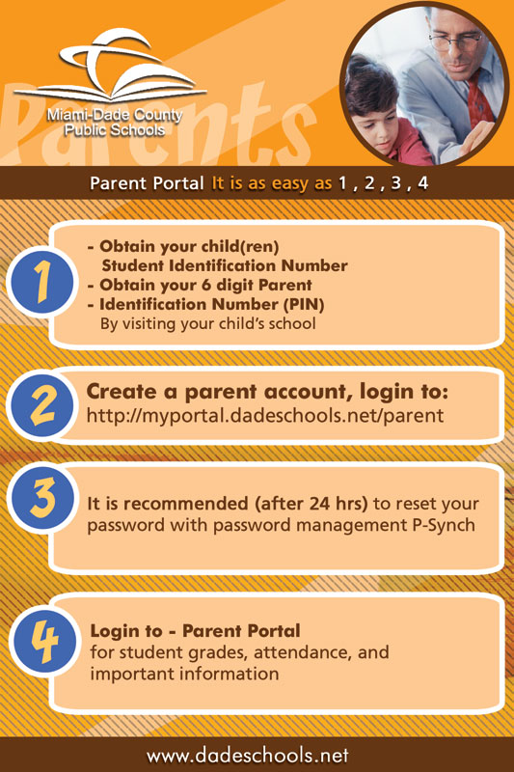

**Financial Obligations**

All financial obligations incurred, i.e. school fees, textbook loss or damage, overdue or lost library books, must be paid in the school treasurer’s office.

**Grade Reporting**

***Academic Grades***

Academic grades are to reflect the student’s academic progress based on the competencies/benchmarks for the grade level/course in which the student is enrolled. The grade must not be based upon student’s effort and/or conduct.

|  |  |  |  |
| --- | --- | --- | --- |
| **GRADES 1-12** | **NUMERICAL**  **VALUE** | **VERBAL INTERPRETATION** | **GRADE**  **POINT VALUE** |
| A | 90-100% | Outstanding progress | 4 |
| B | 80-89% | Above average progress | 3 |
| C | 70-79% | Average progress | 2 |
| D | 60-69% | Lowest acceptable progress | 1 |
| F | 0-59% | Failure | 0 |
| I | 0 | Incomplete | 0 |

***Conduct***

Conduct grades are to be used to communicate to both students and their parents/guardians the teacher’s evaluation of a student’s behavior and citizenship development. These grades are independent of academic and effort grades.

***Grade Point Average***

When calculating the grade for a semester or an annual course, the following grade point averages are to be used:

A = 3.50 and above

B = 2.50 – 3.49

C = 1.50 – 2.49

D = 1.00 – 1.49

***Interim Progress Report***

Interim progress reports must be sent home **at any time** the student is performing unsatisfactorily in academics, conduct, or effort, and are disseminated to all students at mid-grading period.

**Homework / Make-up Assignments**

Teachers are required to provide students with make-up assignments once the absence has been excused; however, it is the responsibility of the student to request the assignments from the teacher(s).

**Out of Area Student Transfer – Board Policy 5131**

Students in the regular school program (K-12) are assigned to attend school on the basis of the actual residence of their parent or legal guardian and the attendance area of the school as approved by the Board. A student may request an out of area transfer if the student resides with parent or legal guardian, and a change of residence occurs. The Region Superintendent (or designated Region Director) may administratively assign or approve the reassignment or transfer of students when the Florida Inventory of School Houses (FISH) capacity of the receiving school is below 100 percent.

In the event a student with an Individual Educational Plan (IEP) requests to attend a school other than the school in which the student is enrolled, parent(s)/guardian(s) must meet with Region Center special education personnel to ensure that the programmatic needs of the student can be met at the requested school.

**Textbooks**

Textbooks will be given out when available within the first several weeks of school. Most books are also available to students through the online portal on the dadeschools.net website.

**Permanent Records (FYI – from the Student Educational Records Manual)**

Miami-Dade County Public Schools maintains the records ofstudents in PK-12 and adult/vocational students enrolled in high school completion programs or vocational programs of 450 hours or more. Permanent records consist of the following student information:

1. pupil’s or student’s full legal name
2. authenticated birth date, place of birth, race, and sex
3. last known address of pupil or student
4. names of pupil’s or student’s parent(s) or guardian(s)
5. name and location of last school attended
6. number of days present and absent, date enrolled, date withdrawn

g)  courses taken and record of achievement, such as grades, credits, or certification of competence

h)  date of graduation or date of program completion, including a statement of diploma, that is,

standard, special, certificate of completion, or General Equivalency Diploma

i)  State and/or District standardized assessment/achievement test results, if required for graduation

j)  written records of access to the student’s record

k)  Home Language Survey

**Procedures for Addressing Concerns**

For issues involving an individual teacher or class, parents address their concerns to the following individuals in the order below.

**School Center for Special Instructions (SCSI)**

School administrators may elect to assign students to the School Center for Special Instruction (SCSI) as an alternative to suspension from school. The center is designed to provide tutorial and guidance services. When misconduct in a class results in an assignment to SCSI, the student should be removed from only the class in which the misconduct occurred. Continued misconduct can result in removal from all classes.

**Transportation Eligibility**

Students will be assigned for transportation to and from school on a M-DCPS bus if the distance between the home and the school exceeds two miles (2), or if the distance between the home and the nearest bus stop exceeds 1 ½ miles. Students who do not meet these distance requirements are not eligible for transportation services. Special provisions may be made for Special Education students based on the requirements of their Individualized Education Plan (IEP).

**Safety and Security**

***The Emergency Operations Plan***

Student and employee safety is a primary concern of the Miami-Dade County Public School (M-DCPS) System. The Emergency Operations Plan (EOP) was created to provide school personnel with the necessary leadership skills and knowledge needed to respond to critical incidents or other related emergencies that may occur in our schools /community. All schools have a site specific plan to address all types of critical incidents. These plans address the individual needs of the school, and provide guidelines for devising methods for communicating with the staff, students, parents/guardians, and the media during a critical incident or an emergency. Some of the protective action procedures include the evacuation of students/staff from the building(s), evacuation of the disabled and if necessary the relocation of students/staff from the school campus, lockdown procedures and holding/dismissing students during school and community emergencies. Some important tips for parent/guardians to remember during a Critical Incident are as follows:

* Remain calm;
* Monitor media outlets for updates and official messages from M-DCPS;
* Do not flood the school with telephone calls; and
* If the school is on lockdown, wait until the lockdown is lifted before going to the school.

All school administrators, Region Center Superintendents/Directors and all M-DCPS Police officers have been adequately trained in the school EOP and are prepared to respond immediately during a critical incident or emergency to provide safety for all children.

***Accident Reports***

Any student who witnesses an accident or is injured in school should report it immediately to the nearest staff member.

***Code Yellow/Code Red***

In the event of an emergency, the primary responsibility of all school personnel is to provide for the safety of all students. In the event a school administrator announces a possible threat to students and staff safety exists within the community (Code Yellow), or an imminent threat to students and staff safety exists within the school (Code Red) students, faculty and staff will comply with all the procedures outlined in the Miami-Dade County Public Schools Critical Incident Response Plan and remain on lockdown until a school administrator makes an “All Clear” announcement.

***Closing of School***

The emergency closing of a school for any cause, such as weather or in which the safety of individuals may be endangered, is only at the discretion of the Superintendent of Schools.

***Fire Drills***

Ten fire drills will take place according to the Miami-Dade County Public Schools Policy and Emergency Procedures. At the sound of the emergency bell, students must stop what they are doing and follow the teacher’s instructions. They must clear the building promptly by the prescribed route. Any student who is in the hallway or the restroom at the sound of the emergency bell must proceed to the nearest exit and locate the teacher. Students, teachers and staff must remain outside the building until permission is given to re-enter.

***Bicycles/Skateboards***

Students are allowed to ride skateboards and bicycles to school but cannot bring them to class. Skateboards are to be locked in the skateboard lock system outside the cafeteria. Bicycles are to be locked by the student parking lot.

***Identification Cards***

Student identification cards are issued early in the school year, and must be worn by students at all times.

***Parking***

Parking decals for all motor vehicles, including mopeds and motorcycles, will be required for students parking at the school. Vehicles without parking decals will be ticketed or towed at the owner’s expense.

***Visitors***

Due to legal regulations, students are not permitted to have guests attend school with them at any time. Parents/guardians are always welcome and tours may be arranged to view the school. Classroom visits require a 24-hour notice. Visitors must first register with security at the main entrance, sign-in and produce photo identification, and then proceed to register in the main office. Anyone who fails to follow these procedures will be considered a trespasser and is subject to arrest.

***Elevator***

The school elevator is to be used by individuals who are handicapped and cannot use the stairs.

**Media Center**

Media center policies and information can be found on our school website under INFORMATION CENTER

**Special Education**

The School Board of Miami-Dade County ensures that all students suspected of having a disability are identified, evaluated, and provided appropriate, specially designed instruction and related services, if it is determined that the student meets the state's eligibility criteria and the parent consents to initial placement.

Prior to referral for evaluation, the student must have participated in the school's Progress Monitoring Plan (PMP) program and have been referred to the school's intervention team.

Students with disabilities who are eligible and require special education will have an Individual Educational Plan (IEP). The IEP describes the student's strengths and weaknesses and documents the services and supports the student needs in order to access a Free and Appropriate Public Education (FAPE) in the least restrictive environment (LRE).

The IEP is a working plan that must be developed by the IEP team at least once every 12 months and reviewed, when appropriate, to revise and address any lack of expected progress toward annual goals, or to consider any new information that has been provided through re-evaluation or by the parent/guardian.

Parent involvement in the special education process is very important. Parents will be asked to participate in the IEP process each year and to consider the need for their child's re-evaluation at least once every three years.

The Individuals with Disabilities Education Act (IDEA) states that parents of a child with a disability have certain procedural safeguards. The *Summary of Procedural Safeguards for Parents of Students with Disabilities* documents all the information about the rights of parents/guardians. This notice of procedural safeguards is made available to the parent.

Rights that are presented in the procedural safeguard document include, but are not limited to, the right of prior written notice; informed consent; participation in meetings; records, independent educational evaluation, mediation, state complaint; local education agency complaint; due process hearings; resolution meetings; due process; attorney fees; discipline; and private school placement.

As the parent/guardian of a child with disabilities, you are a very important member of the team that plans your child's education. Be informed and get involved. If you have any questions, please contact your child's school. Staff from the special education department and your child's student service provider will help to answer your questions. Additional information may also be found at <http://ese.dadeschools.net/>.

**The Parent Academy**

The Parent Academy is a free, year-round, parent engagement and skill building program of Miami-Dade County Public Schools (M-DCPS). The goals are to educate parents about the importance of their role; strengthen the family unit; unite families and schools; and inform parents of their rights, responsibilities and the educational opportunities available to their children and to them personally.

In addition, The Parent Academy provides classes and workshops for parents/guardians; organizes Family Learning Events; coordinates the availability of M-DCPS and community resources for parents/guardians.

Within this framework, The Parent Academy offers classes and workshops developed around the five subject area strands listed below:

* Help Your Child Learn (*Example: PASSport to Success – 8 module series)*
* Parenting Skills (*Example: Positive Discipline)*
* Arts & Culture (*Example: Enrich Your Child through Arts and Culture in Miami)*
* Health and Wellness *(Example: Preventing Substance Abuse)*
* Personal Growth (*Example: Parent Portal)*

The Parent Academy “campus” is spread throughout every corner of this community, and offers free classes and workshops at over 250 local sites such as public schools, libraries, parks, colleges, private businesses, and neighborhood centers. Monthly calendars are posted in the *Course Directory* section on The Parent Academy’s Web site at [www.theparentacademy.net](http://www.theparentacademy.net). The Parent Academy staff members are available to provide parents/guardians, students and school sites with guidance and assistance in scheduling workshops. Staff can be reached at (305) 995-2680.

**Volunteer Program**

The School Volunteer Program is responsible for electronic registration, background checks and trainings of volunteers. There are two different levels of volunteerism.

|  |  |
| --- | --- |
| Level 1 - complete a database background check | Level 2 - complete a fingerprint background check |
| * Day chaperones for field trips * Classroom assistants * Math and/or reading tutors. | * Certified Volunteers * Mentors * Listeners/Oyentes * Athletic/Physical Education assistants * Overnight chaperones. |

Any individual interested in volunteering in Miami-Dade County Public Schools must:

* Show a current valid government-issued identification with picture.
* Show a social security card (check name and number).
* Complete a background check.
* Upon clearance, attend an orientation at the school.

The School Board of Miami-Dade County, Florida adheres to a policy of nondiscrimination in employment and educational programs/activities and strives affirmatively to provide equal opportunity for all as required by:

**Title VI of the Civil Rights Act of 1964** - prohibits discrimination on the basis of race, color, religion, or national origin.

**Title VII of the Civil Rights Act of 1964 as amended** - prohibits discrimination in employment on the basis of race, color, religion, gender, or national origin.

**Title IX of the Education Amendments of 1972** - prohibits discrimination on the basis of gender.

**Age Discrimination in Employment Act of 1967 (ADEA) as amended** - prohibits discrimination on the basis of age with respect to individuals who are at least 40.

**The Equal Pay Act of 1963 as amended** - prohibits gender discrimination in payment of wages to women and men performing substantially equal work in the same establishment.

**Section 504 of the Rehabilitation Act of 1973** - prohibits discrimination against the disabled.

**Americans with Disabilities Act of 1990 (ADA)** - prohibits discrimination against individuals with disabilities in employment, public service, public accommodations and telecommunications.

**The Family and Medical Leave Act of 1993 (FMLA)** - requires covered employers to provide up to 12 weeks of unpaid, job-protected leave to "eligible" employees for certain family and medical reasons.

**The Pregnancy Discrimination Act of 1978** - prohibits discrimination in employment on the basis of pregnancy, childbirth, or related medical conditions.

**Florida Educational Equity Act (FEEA)** - prohibits discrimination on the basis of race, gender, national origin, marital status, or handicap against a student or employee.

**Florida Civil Rights Act of 1992** - secures for all individuals within the state freedom from discrimination because of race, color, religion, sex, national origin, age, handicap, or marital status.

Veterans are provided re-employment rights in accordance with P.L. 93-508 (Federal Law) and Section 295.07 (Florida Statutes), which stipulate categorical preferences for employment.